## ID Travel Group

### Set Up ID Travel Group

To partner with ID Travel Group,

**Step 1)** Once you have obtained accurate login information, you need to add this Live Connect Provider into *ClientBase* by going to **Tools|Settings|Live Connect Providers** and clicking *Add*.

Fill in the following fields:

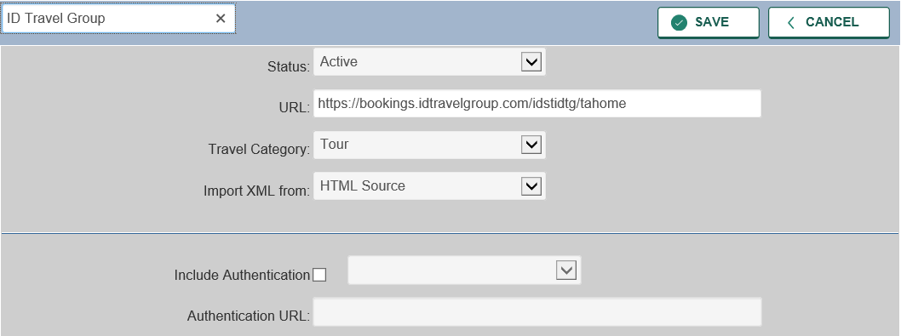

**Name of the Provider:** In blank field provided, type **ID Travel Group**.

**Status:** Leave the default of *Active.* If you ever want to make it *Inactive,* go back in this area to turn off.

**URL:** Type **https://bookings.idtravelgroup.com/idstidtg/tahome**

**Travel Category:** Select **Tour**

**Import XML from:** Select HTML Source.

**Include Authentication:** Leave blank.

Click *Save.*

**Step 2)** Retrieve the **ID Travel Group** vendor profile from the Profile Manager (or create one if not in your database). From the General Info link, click **Add** next to the **Live Connect Providers** label. Select **ID Travel Group** from the drop-down list. The Vendor Code is **IDSTIDTG**.

### ID Travel Group Live Connect Features

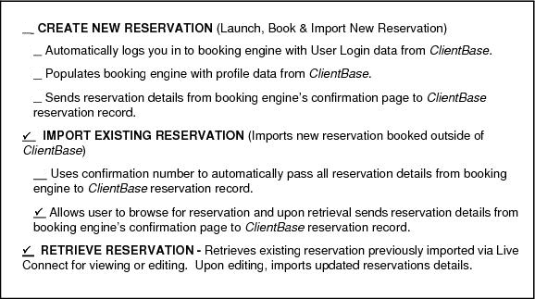

### Importing an Existing Reservation

**Step 1)** Create a new Res Card or open an existing one and launch Live Connect by clicking the Live Connect icon.

**Step 2)** Complete the Live Connect settings by identifying the vendor, the Live Connect Provider and appropriate Login information if not auto-populated.

**Step 3)** Enter the confirmation number for the reservation you want to import and click *Import Existing Reservation.*

**Step 4)** Depending on the Live Connect Provider, the system either locates the reservation using the confirmation number and automatically import all reservation details, or takes you to the Live Connect Provider's site for you to use its Retrieve Reservation feature to locate the reservation. Upon displaying the existing reservation, click *Import Reservation* and the reservation details are imported into the *ClientBase* Res Card.

### 

### Retrieve an Existing Reservation for Editing or Canceling

To edit or cancel an existing reservation using Live Connect, follow these steps:

**Step 1)** Launch Live Connect from inside the Live Connect **reservation** to edit or cancel. Click *Live Connect.*

**Step 2)** Confirm all Live Connect settings including confirmation number, and click *Retrieve Reservation.*

**Step 3)** Live Connect launches the booking engine site. Edit or cancel the reservation using instructions supplied by the booking engine, and click *Import Reservation.* All reservation data edited or cancelled online is now located in the reservation fields in *ClientBase*.